Components to Include on your Site Map
Please Provide a Site Map showing the following (where applicable):
- Buildings, roads, landmarks (for example an image from good maps)
- Activity location and/or routes on the trails/road
- Drop off location for requested infrastructure
- Entrances/exits
- First Aid Station
- Hazards
- Event Structure (tents, beer garden, fencing etc)
  - If you have an area where liquor is being served, please include the dimensions.
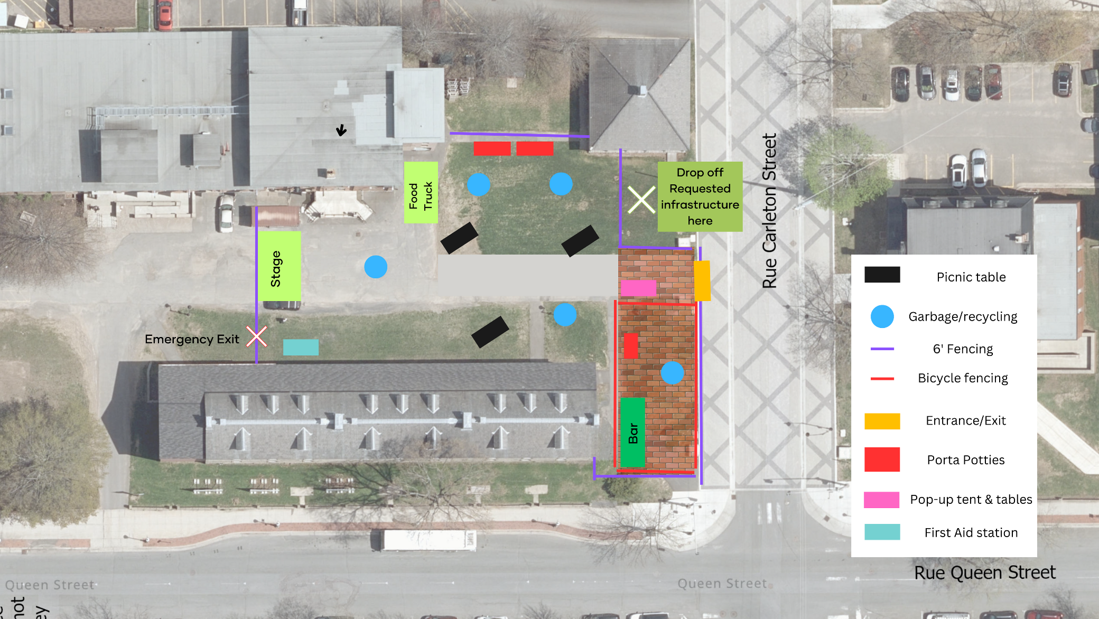
Please see the following for an example of an event map:

